The Foundry
Política y Plan de Participación de Padres y Familias para Compartir el éxito estudiantil
Año Escolar 2020-21
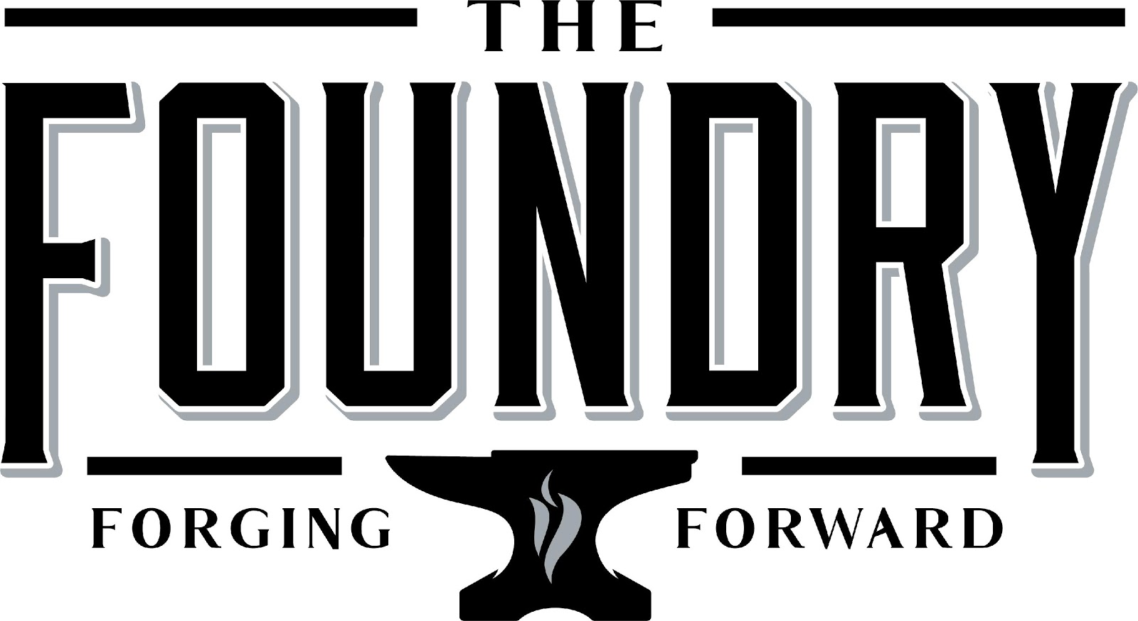
Mitch Murphy, Director
2723 Tumbling Creek Road, Suite B
Gainesville, GA 30504
Thefoundry.hallco.org

Revisado agosto 25, 2020

¿Qué es Título I?
The Foundry se identifica como una escuela Título I como parte de La Ley Cada Estudiante Triunfa (ESSA). Título I está diseñado para apoyar las reformas estatales y de las escuelas locales las cuales están vinculadas con los estándares académicos estatales para reforzar y mejorar la enseñanza y el aprendizaje de los estudiantes. Los programas de Título I deben basarse en medios eficaces para mejorar el rendimiento estudiantil e incluir estrategias para ayudar a la participación de las familias. Todas las escuelas Título I deben desarrollar con todos los padres y familias una política de participación de padres y familias por escrito.

Plan escolar para compartir el Éxito Estudiantil
¿Qué es? Este es un plan que describe cómo The Foundry proporcionará oportunidades para mejorar la participación de los padres para apoyar el aprendizaje de los estudiantes. The Foundry valora las contribuciones y la participación de los padres con el fin de lograr una colaboración mutua con el objetivo común de mejorar el rendimiento estudiantil. Este plan describe las diferentes maneras en que The Foundry apoyará la participación de los padres y cómo los padres pueden ayudar a planificar y participar en las actividades y eventos para promover el aprendizaje de los estudiantes en la escuela y en casa.

¿Cómo se desarrolla? The Foundry invita a todos los padres y familias a asistir a una reunión durante la primavera, para dar sus opiniones y revisar el plan de participación de padres y familias, al igual que la evaluación integral de las necesidades de la escuela/distrito, el plan de mejoras de la escuela/distrito, el convenio entre padres y escuela, además del presupuesto para la participación de los padres. Adicionalmente, recibe las sugerencias de los padres y los comentarios en cualquier momento durante el año escolar en relación con el plan, los cuales se utilizarán para revisarlo para el siguiente año escolar. El plan está disponible en nuestra página de Internet de la escuela para que lo puedan ver y enviar comentarios a lo largo del año. También distribuimos una encuesta en línea y tenemos copias disponibles, pidiendo sugerencias sobre el plan y el uso de fondos para la participación de las familias. Los padres también pueden darnos sus sugerencias durante las diferentes reuniones y actividades de padres que tenemos durante el año.

¿A quién va dirigido? Se anima a todos los estudiantes y sus familias que pertenecen al programa Título I, para que participen plenamente en las oportunidades que se describen en este plan. The Foundry proporcionará todas las oportunidades para la participación de los padres con limitado Inglés, con discapacidades y padres de niños migratorios.
¿Dónde está disponible? Al principio del año escolar, después de la revisión, el plan se publica en la página de Internet de la escuela, se envía por correo electrónico por medio de Infinite Campus, se presenta en la reunión anual de Título I y se ofrecen copias en la recepción de nuestra escuela.

Metas del distrito para el 2020-2021
Meta 1: Al finalizar el FY21, se Incrementará en un 2% el porcentaje de estudiantes en cada subgrupo que se moverán a los niveles de desempeño "Con Dominio" y "Distinguido" en las Evaluaciones de Georgia Milestones

Meta 2: Al finalizar el FY21, se incrementará en un 10% el puntaje de “Cerrar las brechas” (basado en el puntaje de “Cerrar las brechas” del año fiscal 19) en cada nivel (primaria, intermedia y secundaria).

Al finalizar el FY21, se incrementará en un 3% el porcentaje de estudiantes económicamente desfavorecidos que pasan a los niveles de desempeño “Con Dominio” y “Distinguido” en ELA en las Evaluaciones de Georgia Milestones

Metas del The Foundry del 2020-21
- Los maestros monitorearan el progreso y la fijación de metas en clase para alcanzar una tasa de rendimiento del 3% en cada clase en Edgenuity. Durante las reuniones semanales de PLC, el personal de Foundry monitoreara el progreso para hacer seguimiento y desarrollar un plan que brinde apoyo, para asegurar que el 70% de los estudiantes estén en camino de alcanzar el 50% de progreso o más en sus 4 materias principales al finalizar el semestre.

- 100% de los estudiantes de la escuela intermedia del The Foundry completarán un portafolio del programa que abarca todos los 5 componentes clave de alfabetización del Distrito Escolar (lectura, escritura, comprensión auditiva, expresión oral y pensamiento) antes que se les permita volver a inscribirse en su escuela de origen.

- Durante el primer mes de inscripción en el Foundry, el 100% de los estudiantes participarán en una encuesta de interés personal y profesional que se utilizará para desarrollar un plan de transición.

- Durante el año escolar del 2020-2021, 100% de los estudiantes de Foundry se inscribirán en la clase de asesoramiento Real Time para abordar las necesidades de aprendizaje social y emocional de los estudiantes, medido por la finalización de estrategias y actividades.

- El personal en el Foundry trabajará para recibir una calificación de satisfacción del 80% en las preguntas de comunicación con los padres que se mencionan en la encuesta con respecto al ambiente escolar

Convenio entre escuela y padres
Como parte de este plan, el The Foundry y nuestras familias desarrollarán un convenio entre escuela-padres, éste es un acuerdo que los padres, maestros y estudiantes desarrollarán juntos y que explica cómo los padres y maestros trabajarán en equipo para asegurarse de que todos nuestros alumnos alcancen los estándares de nivel de grado. Los convenios serán revisados ​​y actualizados anualmente con base a los comentarios de los padres, estudiantes y maestros. Los convenios se encuentran en el sitio web de la escuela, se comparten a través de la reunión anual de Título I e Infinite Campus. Una copia de este convenio se guarda en la oficina principal por si los padres la necesitan.

¡Vamos a Trabajar Juntos!
The Foundry realizará los siguientes eventos para crear un fuerte compromiso familiar con el fin de apoyar la asociación entre la escuela, los padres y la comunidad para mejorar el rendimiento académico estudiantil.

Jornada de puertas abiertas (Open House) – 20 de agosto de 2020 4:00-7:00p.m.
- Conozca a los maestros de sus hijos y nuestro personal amable de la escuela para este año por medio de Zoom y las presentaciones digitales. Todo el personal escolar estará disponible para ofrecerle sugerencias y estrategias, enfatizando el éxito académico de su hijo para este año y más adelante.

Reunión Anual de Título I – 22 de octubre de 2020 2:00p.m y 5:00 p.m.
- Los invitamos en esta tarde por medio de Zoom y las presentaciones digitales para que aprenda acerca del programa Título I incluyendo nuestra Política de Participación de Padres y familias, el Plan de Toda la Escuela, el Convenio entre Escuela-Padres y los requisitos para padres. Las invitaciones serán enviadas a casa y en la página web de la escuela.

Noche de Información para Padres- 14 de diciembre de 2020 2-6 pm (Puede llegar sin cita, dependiendo de las condiciones, la reunión puede ser vía Zoom).
- Los padres tendrán la oportunidad de hacer una cita con los maestros de su estudiante para conferencias, ver la exhibición estudiantil donde se podrá admirar el trabajo ejemplar y tendremos sesiones de ayuda para los padres (resultados del EOC- ¿Qué significan? portafolio del estudiante, preparándolos para el éxito; transición a la escuela de origen del estudiante, cómo acceder al SLDS, Infinite Campus y Canvas para ayudar al estudiante en casa).

Reunión de Título para recibir sugerencias acerca del Plan de Mejoras de la Escuela, Evaluación Integrales de las Necesidades, Convenio y Plan- febrero 22, 2021, 2020 2:00p.m y 5:00 p.m. dependiendo de las condiciones, la reunión puede ser vía Zoom).
- Padres, familias, e interesados darán aportes al Plan de Mejoras de la Escuela, Evaluación Integral de las Necesidades, Convenio entre Escuela-Padres, Plan de Participación de las Familias, y el Presupuesto para la participación de las Familias.

Noche de Información para Padres- 10 de mayo, 2021, 2-6 pm (Puede llegar sin cita, dependiendo de las condiciones, la reunión puede ser vía Zoom).
- Los padres tendrán la oportunidad de hacer una cita con los maestros de su estudiante para conferencias, ver la exhibición estudiantil donde se podrá admirar el trabajo ejemplar y tendremos sesiones de ayuda para los padres (resultados del EOC- ¿Qué significan? portafolio del estudiante, preparándolos para el éxito; transición a la escuela de origen del estudiante, cómo acceder al SLDS, Infinite Campus y Canvas para ayudar al estudiante en casa).

*Durante TODAS las noches de padres, el personal estará disponible para ofrecer ayuda sobre tecnología a los padres (Infinite Campus, Canvas, etc.) Estas herramientas están disponibles para apoyar a los padres a ayudar a sus estudiantes en casa.

Parental and Family Engagement

La facultad y el personal del Foundry cree que la participación de padres y familias significa un compromiso mutuo, con una comunicación significativa que involucre el aprendizaje académico del estudiante y otras actividades escolares, incluyendo el asegurar:
- Que los padres juegan un papel integral en el aprendizaje de sus hijos.
- Que los padres son animados a participar activamente en la educación de sus hijos en la escuela.
- Que los padres son colaboradores en la educación de sus hijos y se incluyen, como es apropiado, en la toma de decisiones y en los comités asesores para ayudar en la educación de sus hijos.

The Foundry se compromete a ayudar a nuestros padres para que atiendan las actividades mencionadas en este plan. Por favor llame o envíenos un correo si usted necesita asistencia con cuidado para niños o trasporte para poder participar en nuestros programas.
770-534-6857
Thefoundry.hallco.org

¡The Foundry se está diversificando!

La facultad y el personal de ALC tomará las siguientes medidas para promover y apoyar a los padres y familias como un componente importante de la escuela con el fin de fortalecerla y alcanzar nuestras metas escolares. Lo haremos de la siguiente manera:

- Asegurar que toda la información relacionada a la escuela, los programas para padres, reuniones y otras actividades sea ofrecida en inglés y español, publicada en la página de Internet de la escuela y enviada a por correo electrónico a través de Infinite Campus.
- Entrenar cuatro veces al año, por medio de Canvas, al personal escolar con respecto a estrategias para mejorar la comunicación con los padres e ideas para aumentar la participación de las familias
- Compartir información con los padres acerca de los estándares académicos de la escuela y las evaluaciones, así como las diversas maneras en que ellos pueden monitorear el progreso de sus hijos y trabajar con los educadores. Esta información es publicada en la página de Internet de la escuela en inglés y español.
- Comunicar regularmente a las familias y a la comunidad acerca de los eventos y actividades de la escuela, por medio de llamadas telefónicas, medios sociales, página de Internet y volantes.
- Proveer materiales necesarios durante las conferencias, reuniones y actividades de la escuela para que los padres puedan ayudar a sus hijos a mejorar el rendimiento.
- Trabajar con las universidades locales para aumentar la participación y el conocimiento del plan de participación de padres y familias.
- Escuchar y responder las peticiones de los padres y familias con respecto a actividades adicionales para apoyar su participación.
- Colaborar con las escuelas para ayudar con la transición de los estudiantes que salen del Foundry y regresan a su escuela de origen.

Student Achievement

Estándares de Participación de Padres y Familias

Foundry y nuestros padres han adoptado los estándares nacionales PTA para la asociación entre las escuelas y las familias como el modelo de nuestra escuela para involucrar los padres, estudiantes y la comunidad. Estos estándares son:

1. Acoger a todas las familias
2. Comunicación efectiva
3. Apoyar el éxito estudiantil
4. Defender a todos los niños
5. Poder compartido
6. Colaboración con la comunidad

Equipo de la comunidad escolar

The Foundry invita a todos los padres a unirse al Equipo de la Comunidad Escolar, para compartir ideas y maneras de involucrar a otros padres y familias para crear una cooperación efectiva entre la escuela, las familias y la comunidad. El equipo se reunirá durante el año escolar, pero los padres también pueden presentar sus ideas o sugerencias durante todas las actividades y reuniones, al igual que las encuestas para padres y nuestra página de internet. Si usted desea aprender más acerca de nuestro equipo, por favor póngase en contacto, Bryan Gray, administradora al 770-534-6857 o deje un mensaje en la recepción.

Equipo de la comunidad escolar
- Sí, me gustaría unirme al equipo de la comunidad escolar
- Sí, por favor contácteme para que yo pueda aprender más acerca del equipo de la comunidad escolar
- Sí, me parece una buena idea, por favor manténgame actualizado con respecto a próximas reuniones.
Nombre: __________________________________________________________________________________
Nombre del hijo/a y grado: _______________________________________________________________
Dirección: __________________________________________________________________________________
Número de teléfono: ______________________________________________________________________
Dirección de correo electrónico ___________________________________________________________

_______________________________________
____________________________________________________________________________________________________________________________________________________________________________________________________

Share Your Thoughts
Comparta sus ideas
Queremos saber de sus opiniones. Si tiene alguna sugerencia o si hay alguna parte de este plan que cree que no es satisfactorio con las metas estudiantiles y de la escuela para el logro académico, por favor indíquenos sus comentarios en el espacio correspondiente y deje este formulario en la oficina principal:
Nombre: (opcional) ______________________________________________________________________________________
Número de teléfono (opcional) __________________________________________________________________________
________________________________________________________________________________________________________________________________________________________________________________________________________________________________________________________________________________________________________________________________________________________________________________________________________________________________________________

